OPHID Clients README

The purpose of the document is to outline the functions of OPHID Clients CRUD App

# Launcher

The launcher app ICON is as follows:

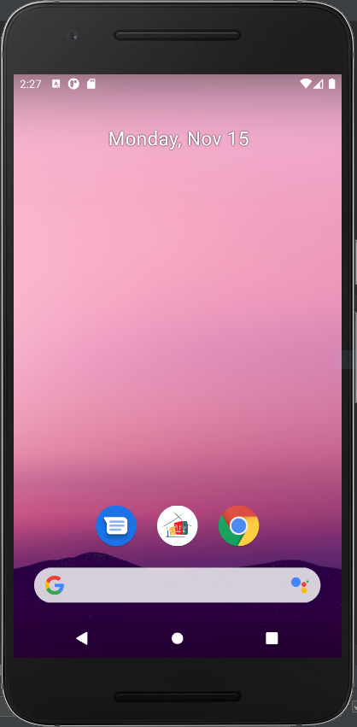

# Clients List / Home Page

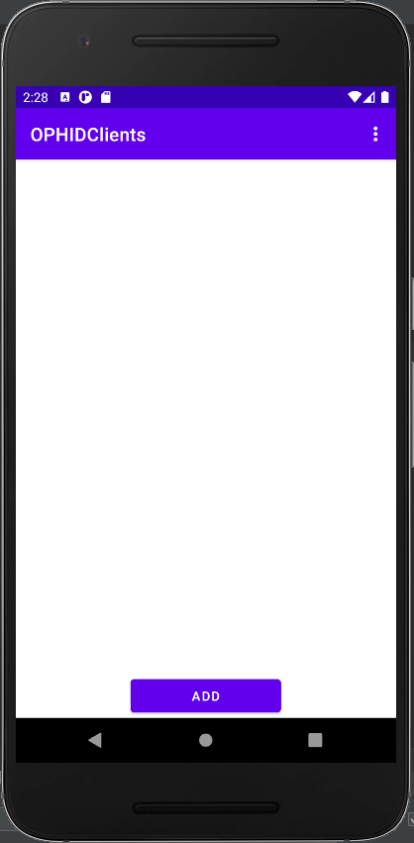

# Add Clients

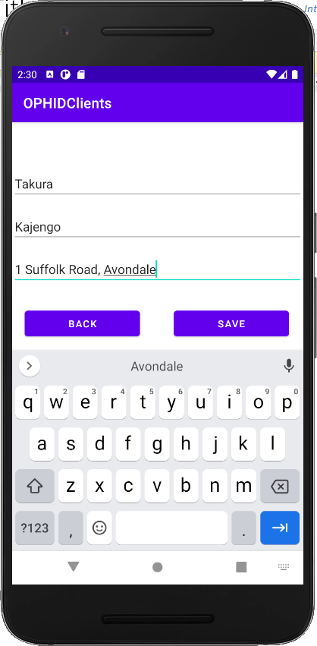

# Populated Client List

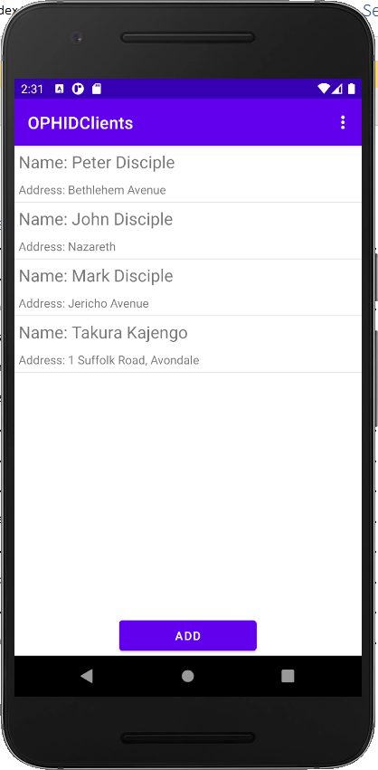

# Show Detail, Edit / Delete Client

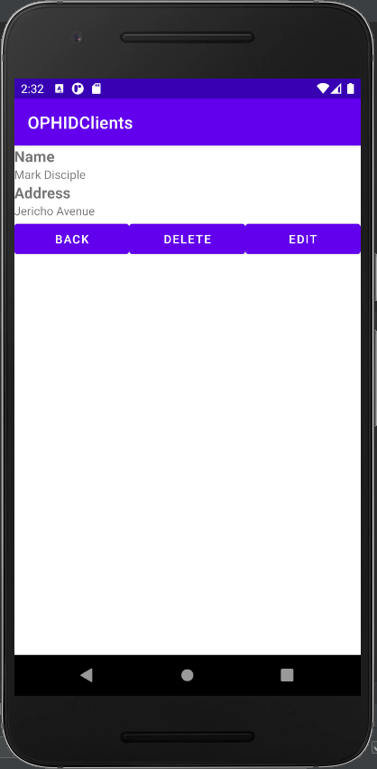

# Edited Client

